Your work is astounding , I am excited. thank you

Let improve on the following
First page,
- Put the logo on the menu tab. This is our emblem and nestling space should be big.
- 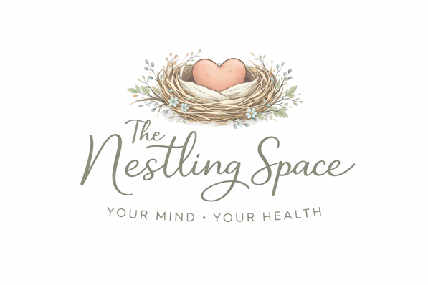

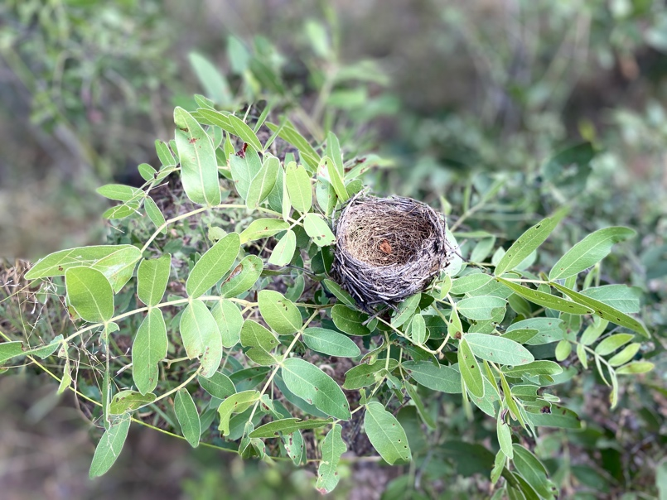

you can use where it fits the natural nest
- can we not have a bright photo of a family something that shows a family in attendance so it can show life.

- Or green leaves or something

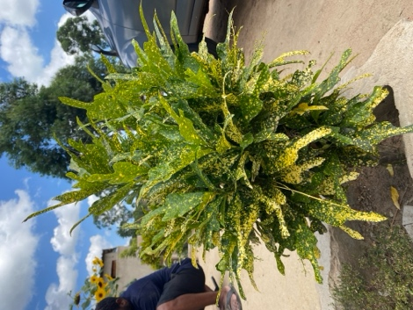

You can edit and remove background

- On wix I had put this, but I am not sure if copy rights will allow this on other websites, but you can look for something nice that show someon deserving compassion and care

2nd page. Who we are is it not supposed to be big
What we offer, hapaiti kuisa tu maphotos here turi bright apo pamatablets ayo

Our founder, pa pic apo panoda kugadziriswa

Get in touch page
Whats app please hide the number like I did on FB, it just has to take them there without displaying the number on both pages

Email yaita but now I need to have the credentials to check the Nestling gmail

Instagram whatsaap buttons not active on this page

FACEBOOK LINK : https://www.facebook.com/profile.php?id=61580743690158

Have you created an Instagram for me a nestling one?

On this page the whatsaap and emails us is active but the form is refusing all the email address I put

On this one,if you get the message that this email will not be secure, I think this will deter them from sending it, and also the email is refusing to go

This is also happening with the feed back form

Our glimpse page uuuum you have to remove the cut and paste coz those were straight from wix , I just wanted you to see what I was doing as guidance. The logo is the nestling space can it be on the header but removed form the pics. Anyone can abuse it

Can we have a header with the access menu to all pages available. Testimonial if yu don’t scroll continuous will not be shown

A small about page, for mision and vision and values

